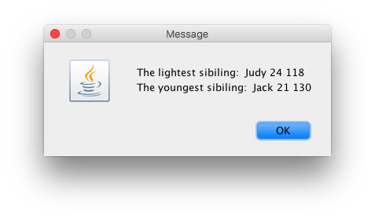

//This assignment allows the user to input 3 siblings, their //weights and ages. Then it determines which is the youngest and //the lightest

**package** As5;

**public** **class** Sibling {

//3 instace private varibales

**private** String name;

**private** **int** age;

**private** **int** weight;

//constrcutor for intitalizing it

**public** Sibling(String name, **int** age, **int** weight) {

**super**();

**this**.name = name;

**this**.age = age;

**this**.weight = weight;

}

//constructor public class_name (data type, data type w)

//constructor this. variable // . means

// click on the varibale and source to generate consturcotr or methods.

//generated methods.

**public** String getName() {

**return** name;

}

**public** **int** getAge() {

**return** age;

}

**public** **int** getWeight() {

**return** weight;

}

}

**package** As5;

**import** javax.swing.JOptionPane;

**public** **class** TestSibling {

**public** **static** **void** main(String[] args) {

String in, out;

String name;

String display;

**int** age, weight;

//need refernce variable

Sibling sib1, sib2, sib3;

//sib points to the object. any ref varibale to point the object. . need one to point to the youngest.

//sibling is the ref variable iwhich points to the objects sib1, sib2

//create input then object

in = JOptionPane.*showInputDialog* ("Enter name");

name = in;

in = JOptionPane.*showInputDialog*("Enter age");

age = Integer.*parseInt*(in);

in = JOptionPane.*showInputDialog*("Enter wight");

weight = Integer.*parseInt*(in);

//the object with 3 paramters. Paramters should match with the constructor

sib1 = **new** Sibling(name,age,weight);

//create input then object

in = JOptionPane.*showInputDialog* ("Enter name");

name = in;

in = JOptionPane.*showInputDialog*("Enter age");

age = Integer.*parseInt*(in);

in = JOptionPane.*showInputDialog*("Enter wight");

weight = Integer.*parseInt*(in);

//the object with 3 paramters. Paramters should match with the constructor

sib2 = **new** Sibling(name,age,weight);

//create input then object

in = JOptionPane.*showInputDialog* ("Enter name");

name = in;

in = JOptionPane.*showInputDialog*("Enter age");

age = Integer.*parseInt*(in);

in = JOptionPane.*showInputDialog*("Enter wight");

weight = Integer.*parseInt*(in);

//the object with 3 paramters. Paramters should match with the constructor

sib3 = **new** Sibling(name,age,weight);

//find the lgihtest. can use if loop. compairson

Sibling lightest = **null**;

**if** (sib1.getWeight() <= sib2.getWeight() &&

sib1.getWeight() <= sib3.getWeight() )

{

lightest = sib1;

}

**else** **if** (sib2.getWeight() <= sib1.getWeight() &&

sib2.getWeight() <= 3)

{

lightest = sib2;

}

**else**

{

lightest = sib3;

}

//create a reference variable for the youngest

Sibling youngest = **null**;

//young

**if** (sib1.getAge() <= sib2.getAge() &&

sib1.getAge() <= sib3.getAge() )

{

youngest = sib1;

}

**else** **if** (sib2.getAge() <= sib1.getAge() &&

sib2.getAge() <= 3)

{

youngest = sib2;

}

**else**

{

youngest = sib3;

}

//output

display = "The lightest sibiling: " +

lightest.getName() + " " +

lightest.getAge() + " " +

lightest.getWeight() + " \n" ;

display = display + "The youngest sibiling: " +

youngest.getName() + " " +

youngest.getAge() + " " +

youngest.getWeight() + " \n";

//display output

JOptionPane.*showMessageDialog*(**null**, display);

}

}